UNITED STATES MARINE CORPS
MARINE BARRACKS
8TH & I STREETS S. E.
WASHINGTON, D. C. 20390-5000
IN REPLY REFER TO:
5 Jan 2015

From: Staff Sergeant Shawn Garber, Marketing & Public Relations Office, Battle Color Detachment
To: Staff NCO or equivalent, Public Affairs Office

Subj: BATTLE COLOR DETACHMENT, PRESS KIT

Encl: Battle Color Detachment Branding Guide

This letter is to inform all pertinent personnel on the upcoming Battle Color Ceremony taking place at your current location, and to provide a means of obtaining advertising opportunities if deemed appropriate. Located on the enclosure is the contact information for myself, SSgt. Shawn Garber, the Marketing & Public Relations representative for the United States Marine Corps Battle Color Detachment.
Please utilize the contact information below if you wish to request any other digital media to assist in providing maximum attendance at the Battle Color Ceremony. Not only is the Battle color Ceremony used as a recruiting tool for the surrounding communities, high schools, and local media, but a unique organization to increase morale for Marines, both former and active, and all other service members and former service members that have the opportunity to witness this display of pageantry and precision.
Local media is a wonderful tool that can be used to help expand the number reached with this event. One-on-one interviews can be scheduled for local television, newspapers, or publications that your own office produces. The likelihood of an interview with members of the Battle Color Detachment is much greater the earlier the interview times, dates, and locations are in place. To expedite the process, it is recommended that the local organization is given the enclosed contact information and the interview is scheduled directly through the Battle Color Detachment Marketing & Public Relations Representative. As well, interviews can be arranged before and after performances and the Battle Color Detachment will strive to facilitate them to the best of our ability, utilizing the Marines we have available. There are several Marines that are from the local areas in which we perform which gives a great opportunity for hometown interviews. The Battle Color Detachment Marketing & Public Relations Office will provide the names of these individuals if this is an option.
The units within the Battle Color Detachment are unique and thus possess a number of specific requirements when marketing them. Along with contacting Marketing & Public Relations for any questions regarding these requirements, please feel free to visit the Marine Barracks Washington website, the Drum & Bugle Corps website, and the Drum & Bugle Corps Facebook page for more information.

Key social media sites for use:

facebook.com/usmcdrumcorps
facebook.com/marinebarracks
twitter.com/usmcdrumcorps
www.drumcorps.marines.mil
https://www.flickr.com/photos/marinebarracks/8543556212

If there are any questions, please contact me via: cell phone (434) 825-3671 and either garber.drumcorps@gmail.com or shawn.garber@usmc.mil as a secondary means.

Respectfully,

SSgt. Shawn W. Garber

(Encl 1)

Battle Color Detachment Branding Guide

- When printing or utilizing information regarding the Battle Color Detachment please consider the following:

1. Three units from Marine Barracks Washington, D.C. make up the

(Official Title)
United States Marine Corps
Battle Color Detachment.

They Are:

(Official Titles)
“The Commandant’s Own,”
The United States Marine Drum & Bugle Corps

The United States Marine Corps
Silent Drill Platoon

And

The official Color Guard of the Marine Corps

- Titles may be shortened after initial mention to:

“The Commandant’s Own” or U.S. Marine Drum & Bugle Corps

The Silent Drill Platoon

And

Color Guard of the Marine Corps

- Please utilize this verbiage when speaking of, printing, or utilizing the verbiage in digital media.

Battle Color Detachment Branding Guide

- A description of each logo associated with the detachment is as follows:

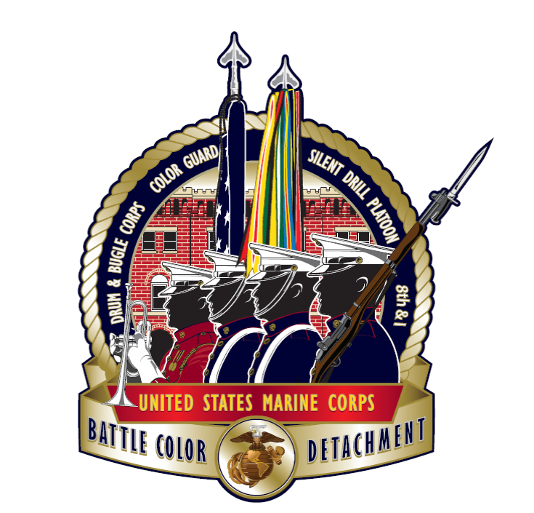
Official Battle Color Detachment Logo

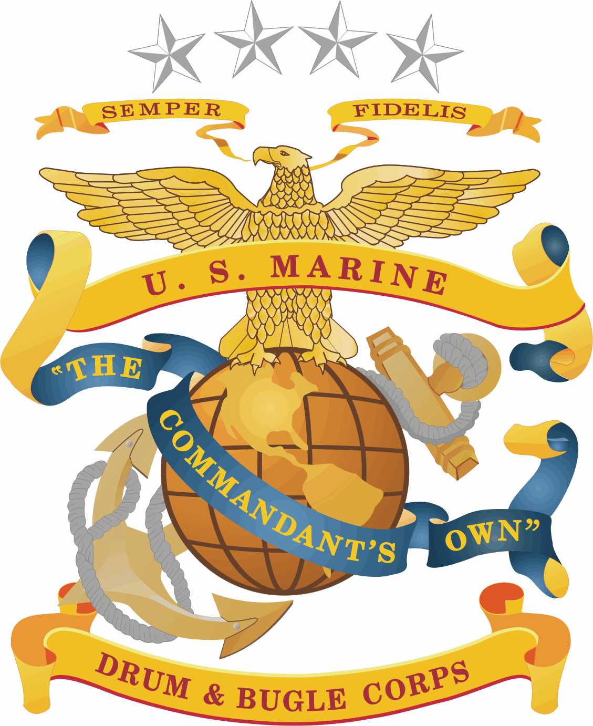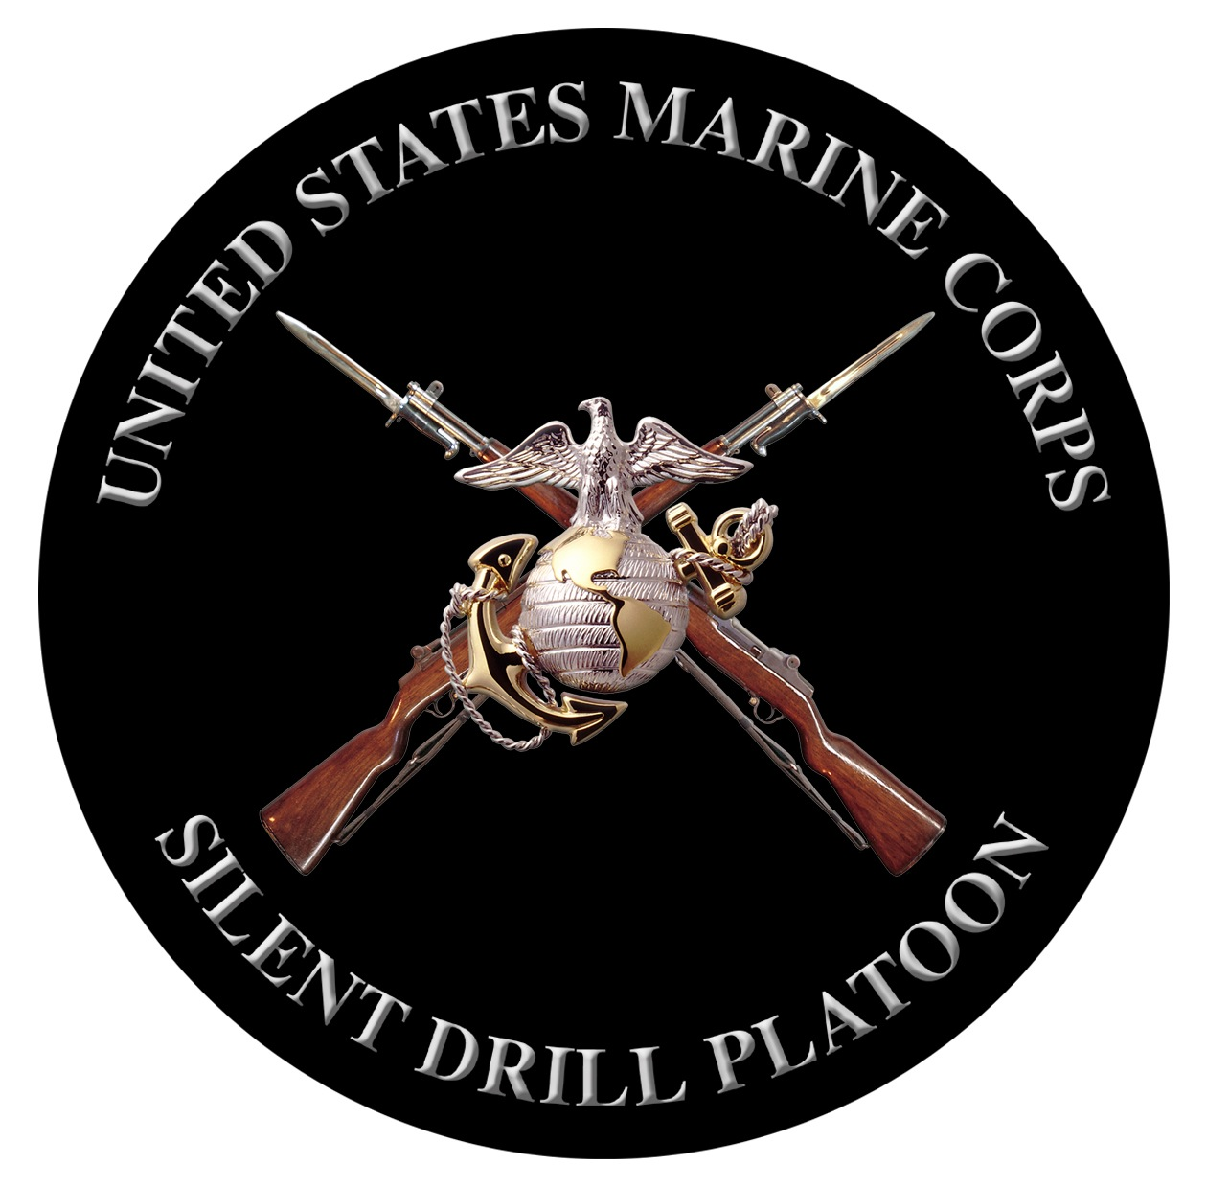

Official Silent Drill Platoon Logo
Official Logo
“The Commandant’s Own”
The United States Marine Drum & Bugle Corps

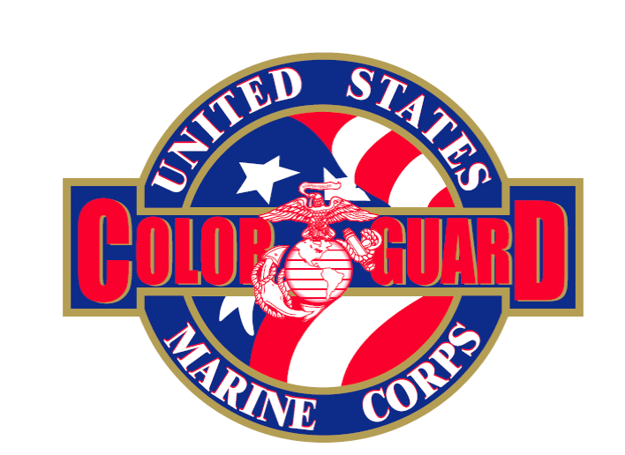
Official Color Guard Logo

